Variables and data types are fundamental concepts in programming that play a crucial role in storing and manipulating data. They are the building blocks of any computer program, enabling developers to work with information, perform calculations, make decisions, and create more complex and dynamic applications.

1. Variables:

- Variables are symbolic names used to represent and store data in a program. They act as containers that can hold different types of information and provide a way to give a meaningful name to a piece of data, making it easier to understand and manipulate within the code.

- Variables can be local (limited to a specific function or block of code) or global (accessible throughout the program).

2. Data Types:

- They define the kind of data a variable can hold, including integers, floating-point numbers, strings, and more. Different data types have distinct characteristics and are used for various purposes.

Common data types include:

- Integer: Used for whole numbers (e.g., 1, -42).

- Floating-Point: Used for numbers with decimal points (e.g., 3.14, -0.5).

- String: Used for text and sequences of characters (e.g., "Hello, World!").

- Boolean: Used to represent true or false values.

- Arrays/Lists: Used to store collections of values, often of the same data type.

- Objects/Structures: Used to encapsulate multiple pieces of data into a single entity

So then what are the roles of Variables and Data Types in?

1. Storing Data: Variables store values of specific data types, allowing you to preserve information for later use in your program.

Let us then see an example with python:

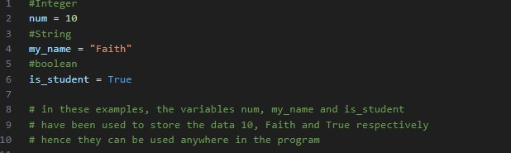

1. Manipulating Data: You can perform operations on variables, such as addition, subtraction, concatenation for strings, comparison, and more.

Let us then see an example to understand better:

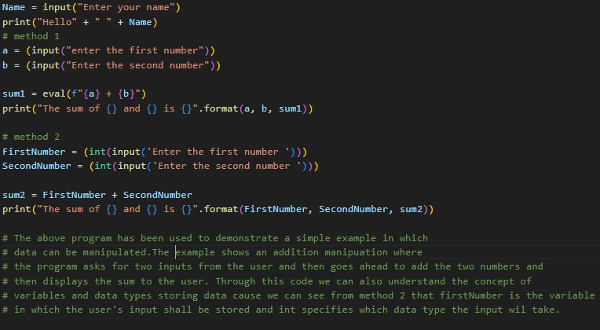

Apart from storing and manipulating data, variables and data types can take up the following roles :

- Providing Context: Meaningful variable names and appropriate data types make code more readable and self-explanatory, enhancing maintainability.

- Enabling Conditional Statements: Variables help control the flow of a program by storing data that can be tested using conditions (if-else statements).

- Iteration: In loops, variables are often used to iterate through collections or perform repetitive tasks.

- Parameter Passing: In function and method calls, variables can be used to pass data as arguments to the functions.

- Dynamic Data Handling: Variables can change their values during program execution, making programs adaptable and responsive.

In summary, variables and data types are fundamental concepts that allow programmers to work with and manipulate data in their programs, enabling the development of dynamic and functional software. The choice of data types and variable names is essential for code clarity, efficiency, and correctness.